Public Participation Task Application

The Public Participation Task Force membership provides ongoing opportunities for interested residents of DVRPC’s nine-county region (Bucks, Chester, Delaware, Montgomery, and Philadelphia in Pennsylvania; and Camden, Burlington, Gloucester, and Mercer in New Jersey) to learn more about the regional planning and decision-making process from DVRPC staff and to share their thoughts on how DVRPC can improve its engagement process.

By applying to become a member of the Task Force, you understand that you will be working alongside other region residents to work with DVRPC to establish a diverse and engaged body to address the region's planning and public participation practices throughout DVRPC’s nine-county region. This application is an opportunity for you to share with us your personal experience living in the region and planning projects. We take a holistic approach to selecting task force members. We are interested in hearing your thoughts about your community's future and transportation needs, regardless of your experience with transportation or planning projects.

Due to the Task Force’s mission of engaging residents who do not already play a role in the planning process elected officials are not eligible to serve as at-large members of the Task Force. The Commission provides a range of other opportunities to engage with the region's municipal and county governments. If you are an elected official, the Commission welcomes your participation in its other plans, programs, and task forces.

For questions on the Public Participation Task Force or this application, contact Wideleine Desir, Public Participation Planner, at wdesir@dvrpc.org or 215-238-2853.

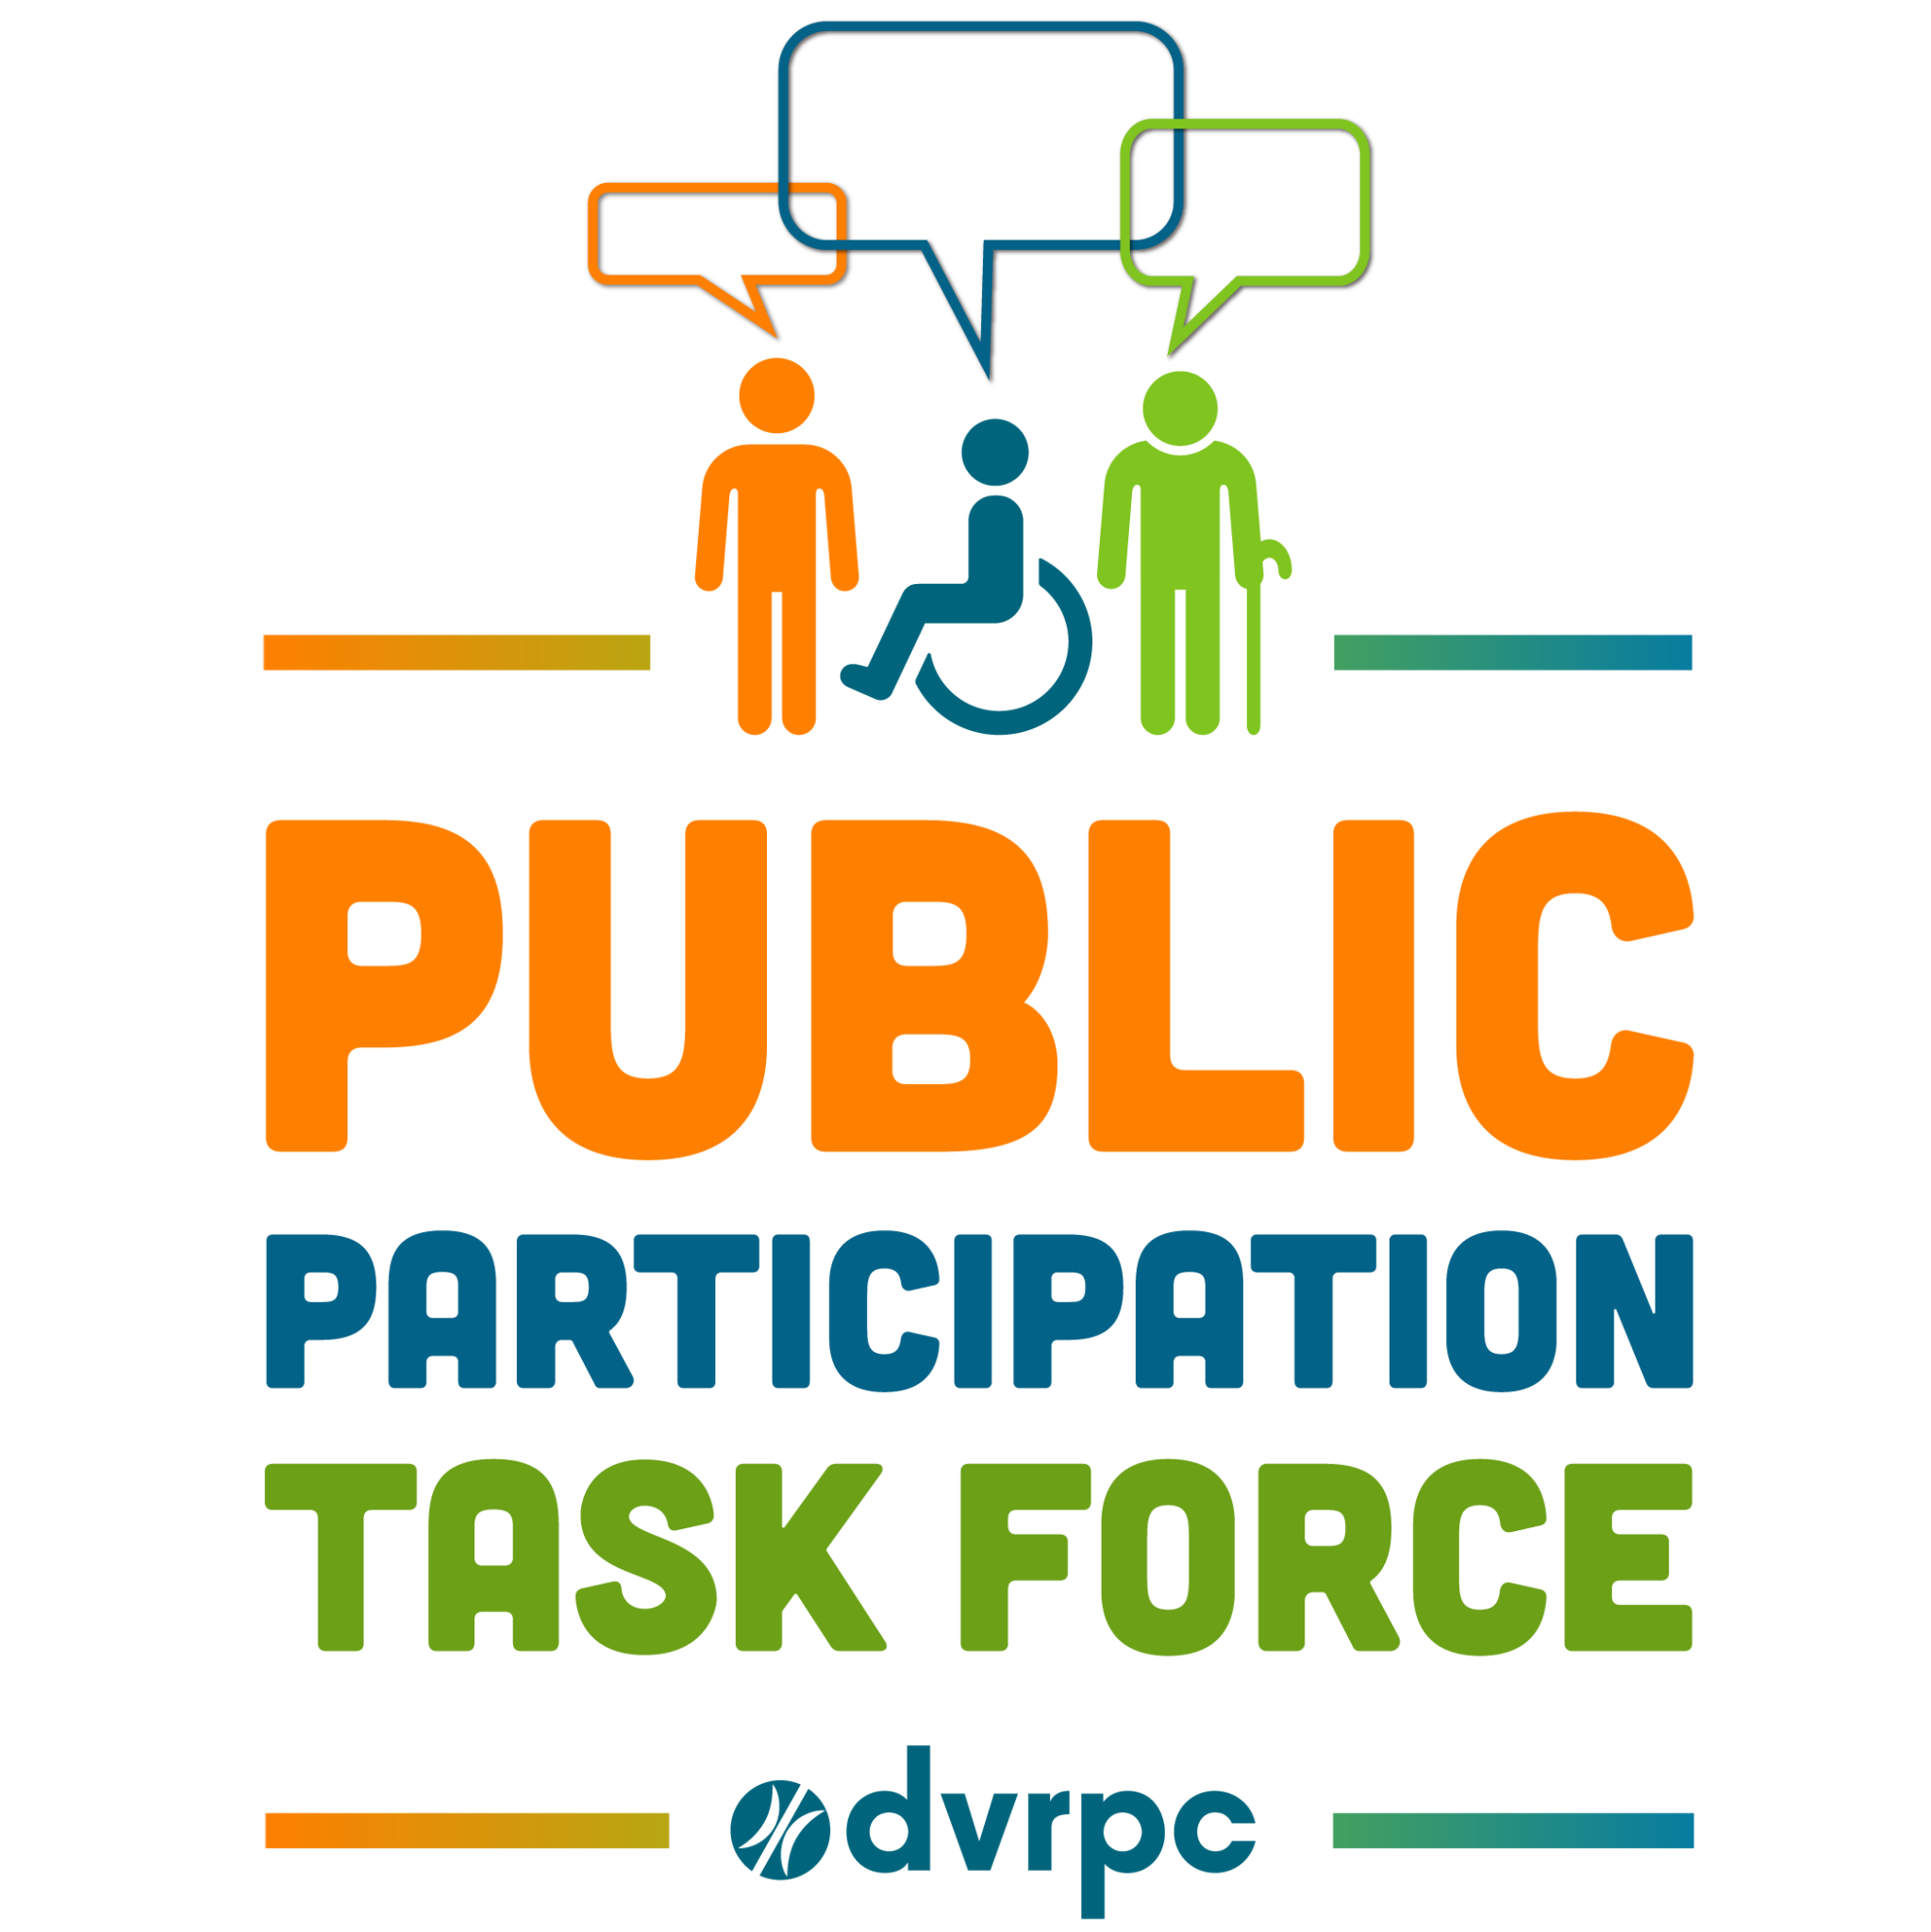
About You

First Name: ____________________

Last Name: ____________________

Email: __________________________________

Home Address: ___________________________

City: ____________________________________

Zip: _____________________________________

County: __________________________________

Mailing Address (if different from above):

______________________________________________________________________

______________________________________________________________________

Phone Number: ____________________________

Occupation: ________________________________

How long have you lived in DVRPC’s region?
- Less than one year
- 1-5 years
- 6-10 years
- 11-20 years
- Over 20 years

How did you out about the Public Participation Task Force?
- DVRPC’s social media or newsletter
- Other organization’s social media (please specify)
- Other organization’s newsletter (please specify)
- Word of mouth (please specify)
- Other (please specify
Experience and Interest

List any experience from the past five years that you feel supports your application to become a Task Force member. Examples of this experience include working on community organizations, boards, agencies, volunteer groups, school groups, and part-time or seasonal work such as poll worker, library aide, PTA, etc.

Experience #1

Organization ___________________________________________

City, State ________________________, _______________

Start date (MM, YYYY) ____________ End date (MM, YYYY) ________________

Brief description of your role
_____________________________________________________________________
______________________________________________________________________

Experience #2

Organization ___________________________________________

City, State ________________________, _______________

Start date (MM, YYYY) ____________ End date (MM, YYYY) ________________

Brief description of your role
_____________________________________________________________________
______________________________________________________________________

Experience #3

Organization ___________________________________________

City, State ________________________, _______________

Start date (MM, YYYY) ____________ End date (MM, YYYY) ________________

Brief description of your role
_____________________________________________________________________
______________________________________________________________________
Statements of Interest

The purpose of the Task Force is to meaningfully engage with residents in the region, create an educational forum for the regional transportation planning process, and elevate the voices of community members. To better understand your interest in joining the PPTF, please answer the questions below with short responses.

- Why are you interested in being a member of this task force? (150-word max)
______________________________________________________________________
______________________________________________________________________
______________________________________________________________________
______________________________________________________________________
______________________________________________________________________

- Why are you interested in being a member of this task force? (150-word max)
______________________________________________________________________
______________________________________________________________________
______________________________________________________________________
______________________________________________________________________
______________________________________________________________________

- How would you contribute to the task force if selected? (150-word max)
______________________________________________________________________
______________________________________________________________________
______________________________________________________________________
______________________________________________________________________
______________________________________________________________________

- What concerns or topics would you like to discuss in the task force? Why? (150-word max)
______________________________________________________________________
______________________________________________________________________
______________________________________________________________________
______________________________________________________________________
______________________________________________________________________
______________________________________________________________________
Check off your areas of experience. (Select all that apply.)
Experience includes academic, personal experience, paid work, or volunteer experience in the topic area.

- Bicycle, Pedestrian, or Transit Planning
- Climate Change or Environmental Justice
- Community Engagement
- Geographical Information Systems (GIS)
- Good movements or Freight
- Housing or Land Use Planning
- Incident Management and First Responders
- Intelligent Transportation Systems (ITS)
- Public Health
- Research, Policy, or Data Analyst
- Transportation Safety
- Other (please specify) ______________________________________

Check off areas you would like to learn more about. (Select all that apply.)

- Bicycle, Pedestrian, or Transit Planning
- Climate Change or Environmental Justice
- Community Engagement
- Geographical Information Systems (GIS)
- Good movements or Freight
- Housing or Land Use Planning
- Incident Management and First responders
- Intelligent Transportation Systems (ITS)
- Public Health
- Research, Policy, or Data Analyst
- Transportation Safety
- Other (please specify) ______________________________________
More About You

Task Force membership will ideally represent the region by geographic and demographic diversity. Please help us create a more inclusive group by sharing some of your demographic characteristics.

Age
- 17-19 years
- 20 to 24 years
- 25 to 34 years
- 35 to 44 years
- 45 to 54 years
- 55 to 59 years
- 60 to 64 years
- 65 to 74 years
- 75 to 84 years
- 85 years and over

Race/Ethnicity (Select all that apply.)
- Hispanic, Latino, or Spanish origin (Mexican, Brazilian, Spaniard, etc.)
- Black or African-American (Jamaican, Haitian, Ethiopian, Somali, etc.)
- Asian (Chinese, Vietnamese, Korean, Hmong, Pakistani, Indian, etc.)
- Native Hawaiian or Pacific Islander (Chamorro, Samoan, Tongan, etc.)
- White non-Hispanic (German, Irish, Italian, French, Polish, Russian, etc. )
- Middle Eastern or North African (Yemeni, Turkish, Moroccan, Sudanese, etc.)
- Native American or Alaska Native (please specify): ______________________
- Other (please specify): ___________________________

Preferred Pronouns
- Sher/Her
- He/Him
- Them/They
- Other (please specify): __________________________________

Do you consider yourself a person with a disability?
- Yes

- No
- Prefer not to answer

Is there anything else you would like to share with us?
______________________________________________________________________
______________________________________________________________________
______________________________________________________________________
______________________________________________________________________
______________________________________________________________________

Thank You!

Applications are accepted year-round and reviewed annually at the end of December. Applications received after December 23rd will be considered for the following Public Participation Task Force. You will be contacted once your application enters the review process.
Return completed applications via email to Wideleine Desir, Public Participation Planner at wdesir@dvrpc.org or via postal service to
Delaware Valley Regional Planning Commission
Attn: Wideleine Desir
190 N Independence Mall West, 8th floor
Philadelphia, PA 19106

The Delaware Valley Regional Planning Commission (DVRPC) fully complies with Title VI of the Civil Rights Act of 1964, the Civil Rights Restoration Act of 1987, Executive Order 12898 on Environmental Justice, and related nondiscrimination mandates in all programs and activities. DVRPC's website, www.dvrpc.org, may be translated into multiple languages.
Publications and other public documents can usually be made available in alternative languages and formats if requested. DVRPC’s public meetings are always held in ADA-accessible facilities, and held in transit-accessible locations whenever possible. Translation, interpretation, or other auxiliary services can be provided to individuals who submit a request at least seven days prior to a public meeting. Translation and interpretation services for DVRPC’s projects, products, and planning processes are available, generally free of charge, by calling (215) 592-1800. All requests will be accommodated to the greatest extent possible.
Any person who believes they have been aggrieved by an unlawful discriminatory practice by DVRPC under Title VI has a right to file a formal complaint. Any such complaint must be in writing and filed with DVRPC's Title VI Compliance Manager and/or the appropriate state or federal agency within 180 days of the alleged discriminatory occurrence. For more information on DVRPC's Title VI program or to obtain a Title VI Complaint Form please visit www.dvrpc.org/GetInvolved/TitleVI or email public_affairs@dvrpc.org.

